Course code- INT 248

Section – KM086

P.DINESH KUMAR REDDY-

VISHNU CHOPRA - 11805967

Github link -> <https://github.com/vishnu190/Vishnu-chopra-P-Dinesh-kumar-reddy-INT248-CA1>

INTRODUCTION: Language translator using deep learning Algorithm

ABOUT:

A translator is someone who converts the written word from one language to another. An interpreter on the other hand, is someone who translates orally or through sign language interpretation. The translator should be fluent in English language and at least one another language in which they want to work as a translator. The goal of a translator is to have people read the translation as if it were the original. translator translate the sentence in the same flow as the original. A translator must translate in their native language. Mostly all translation work is done on a computer by a translator and a translator may proofread the documents or revised the documents before becoming final.

There are many languages around the globe, but the majority of content we see is in the English language online as well as offline. English is the official language of only seven countries comprising little more than five per cent of the globe’s population. Many corporate people want to talk or communicate in their native language and use the English language as their second language. By using machine translation with the help of python anyone could easily translate the content in one language to another language in real-time. If they own their smartphone they can be familiar with one more facility that they use on a daily basis that is Google Assistant, Siri, and Alexa. They all are using speech to text models, it saves a ton of time of typing an important document. In this project, we will also discuss this technology using Python.

PROJECT SCREEN SHOTS

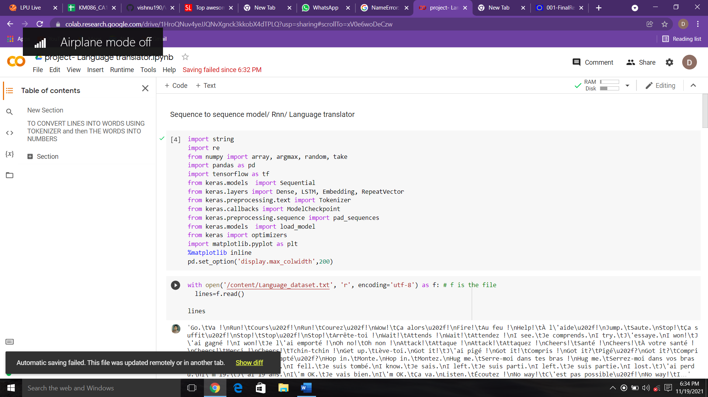

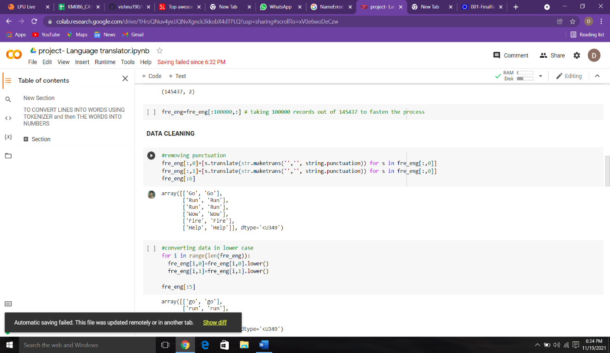 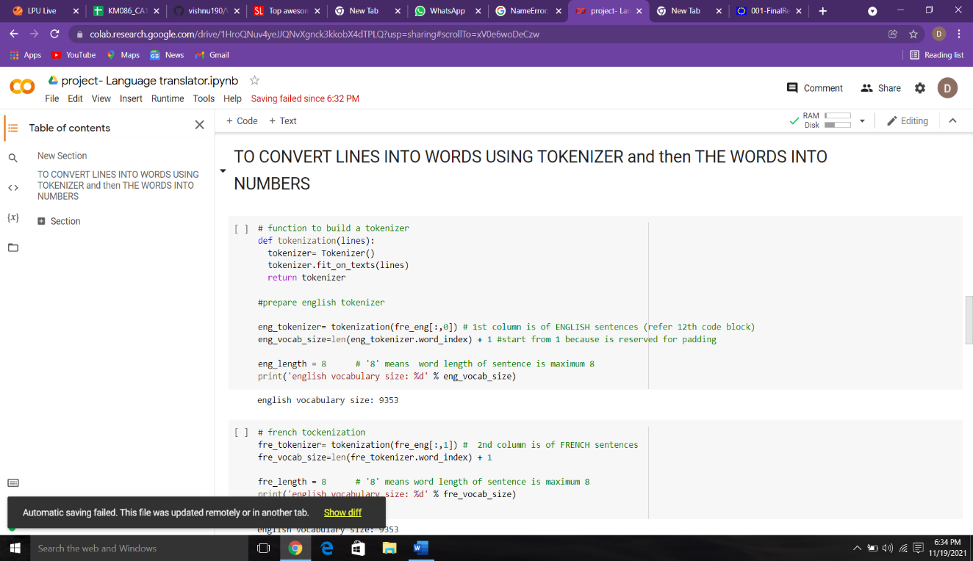

Output :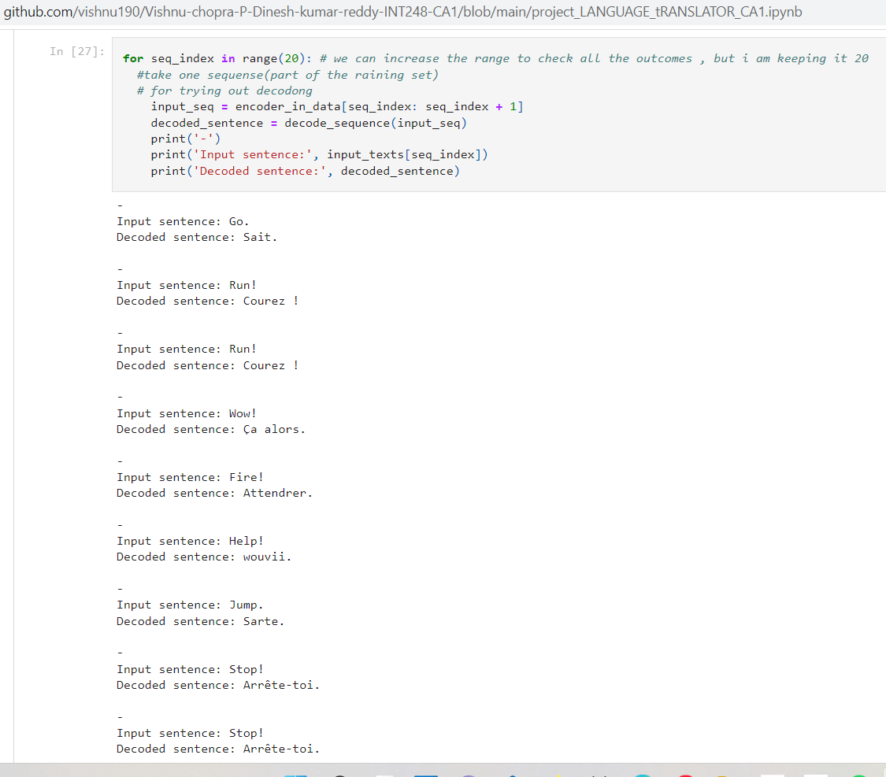

KAGGLE DATASET USED : French-English dataset

# [**sequence-to-sequence learning in Keras**](https://blog.keras.io/a-ten-minute-introduction-to-sequence-to-sequence-learning-in-keras.html)

Sequence-to-sequence learning (Seq2Seq) is about training models to convert sequences from one domain (eg sentences in English) to sequences in another domain (e.g. the same sentences translated to French).

"the cat sat on the mat" -> [Seq2Seq model] -> "le chat etait assis sur le tapis"

*A small example using keras module

LSTM(Long Short term memory)

**The trivial case: when input and output sequences have the same length**

* When both input sequences and output sequences have the same length, you can implement such models simply with a Keras LSTM or GRU layer (or stack thereof). This is the case in [this example script](https://github.com/fchollet/keras/blob/master/examples/addition_rnn.py) that shows how to teach a RNN to learn to add numbers, encoded as character strings

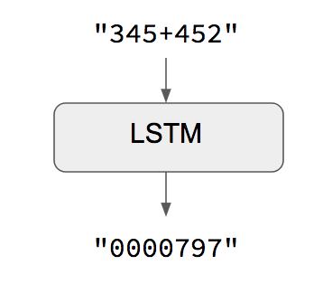

MY UNDERSTANDING TOWARDS LSTM:

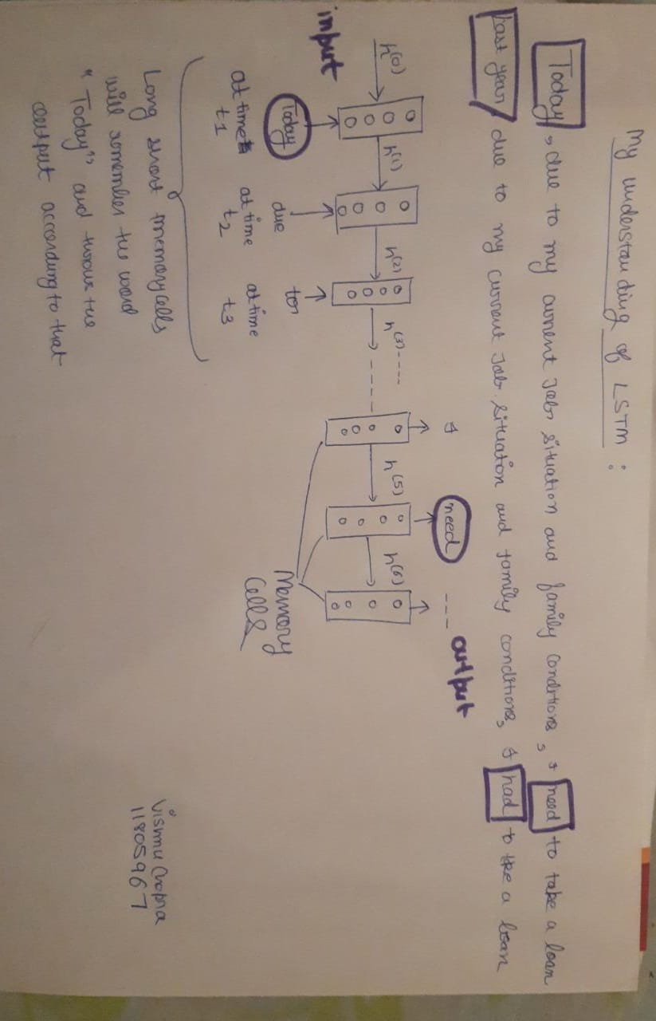

We used RNN (Recurrence Neural network) technique In this project :

*RNNs are designed to take sequences of text as inputs or return sequences of text as outputs, or both.

*They’re called recurrent because the network’s hidden layers have a loop in which the output and cell state from each time step become inputs at the next time step.

*This recurrence serves as a form of memory. It allows contextual information to flow through the network so that relevant outputs from previous time steps can be applied to network operations at the current time step.

Dataset used: Kaggle data set French and english

Proposed architecture:

True translation goes beyond the words used and takes into account layout, style, colors, graphic features, and a wide variety of other matters. The cask of amontillado, text and analysis Amazonas. Translating your presentation professionally will help your audience understand, retain, and ultimately act on your message. Present with real-time, automatic captions or subtitles in PowerPoint. If you continue browsing the site, you agree to the use of cookies on this website. 5. Note: The Presentation Translator add-in for PowerPoint has been retired and is no longer supported. If you're using PowerPoint for Microsoft 365 you already have this functionality built in. 1. Presentation Translator for PowerPoint; Windows; Languages; For Education; More. Each of our projects is backed by the finest in project management, so you’ll never have to worry about unanticipated issues with your PPT language translation. In addition to translating the text so that the foreign verbiage carries the same meanings and connotations, it is also important to localize the format and the way the text is laid out. You may choose to configure your microphone from the Microphone dropdown menu or customize other settings in Additional Settings. 1. In the Slide Show ribbon tab, select Subtitle Settings. MS Office, Adobe, HTML/XML, Scanned Document, etc. From the dropdown bars, select the language you will be speaking in and the desired language to display in subtitles. Use Subtitle Language to see which languages PowerPoint can display on-screen as captions or subtitles and select the one you want. Each of these issues can carry unintended meanings and implications for a target culture; if your localization efforts do not take these into account, you could cause confusion or even offense with your translation.

FUTURE SCOPE:

When we talk about future of translation, many people think about robots translating thousands of words in seconds! But is this what is really awaiting us in the next five or ten years?

Technology has already brought about significant changes in the language service industry. Besides the things everybody sees, like Google Translate or Skype’s translation program, there’s a wide range of changes professionals could only have dreamed of about 20 years ago.

Computer Aided Translation (CAT) tools, instant communication, translation memories, and exhaustive glossaries just one click away are just some examples of how technology has made translators’ lives easier in the last two decades.

There is a good chance that translators producing mediocre translations will be replaced. Machine translations can already produce average to good translations. So why would anyone seek your services if a machine performs better? (The machine won’t even want to take the annual one month off to travel or the weekend off for the second cousin’s wedding!)

Excellent translators with a great command over their target language needn’t be as worried. Machine translation output still needs to be post edited. It is something that is already happening in the language market. Translators get trained and LSPs offer MT+PE as a service.

Technology will become increasingly indispensable. In fact, I would like to believe that it already IS indispensable for a professional translator. But with the advent of AI, better TMS and larger memory corpuses, using CAT tools (computer aided translation tools) will be a foremost requirement. Knowing your source and target languages well won’t be enough. Adapting to new technology as fast and as seamlessly as you can will play a crucial role in deciding how quickly you become redundant.

There is already a major shift to Indian languages. You are a foreign language translator? Great. But it may be time to start working harder on your mother tongue and polishing the other Indian languages that you may know. Demand for translations *into* Indian languages is certainly going up. Many e-commerce companies want to break from their traditional markets and enter the regional Indian markets. Every time you log on to a site to buy anything is an oppurtunity Localisation and translation into Indian languages is the future.

The way ahead is therefore very interesting. Translators need to stay relevant to the industry. Read. Stay informed. Keep up with the pace of development and adapt. Understand the importance of Indian languages.